Test Case: tc001_SPX_Dev5_Crear_Solicitud_Articulo_Almacen
Step 1 - Enter username and password and click to button Enter : Credentials Entered
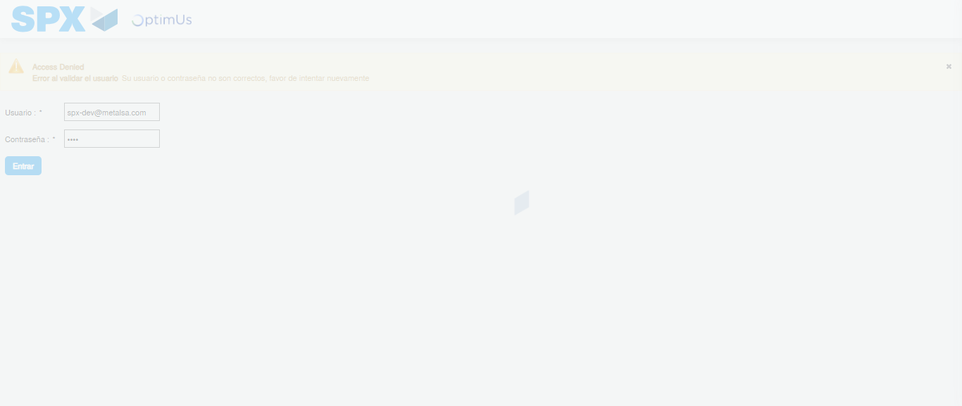Image file-name: QC_Testing-tc001_SPX_Dev5_Crear_Solicitud_Articulo_Almacen-1787938649661

Step 2 - Select to UEN and Access to Request for a New Inventory Item : UEN Correctly selected and Correct access
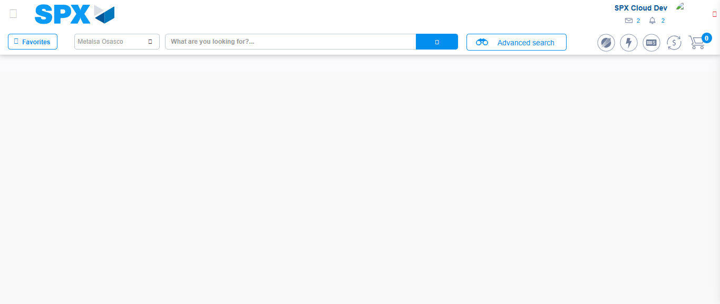Image file-name: QC_Testing-tc001_SPX_Dev5_Crear_Solicitud_Articulo_Almacen-1787938677310

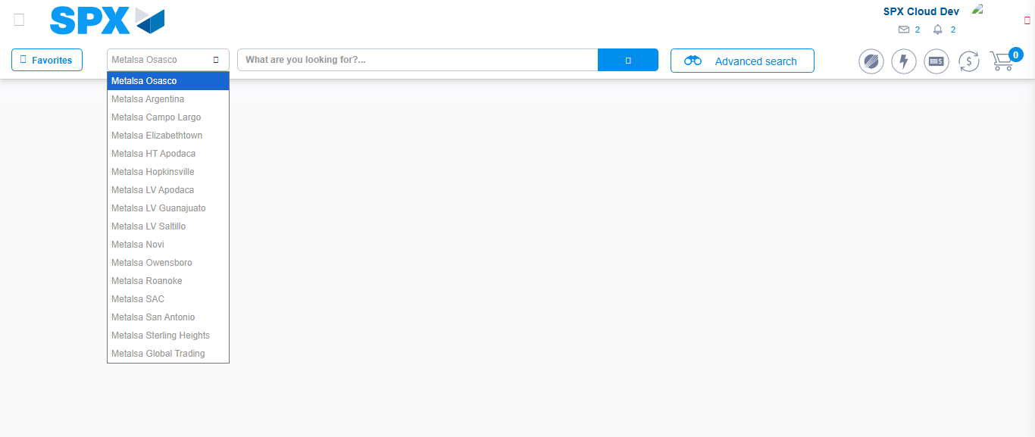Image file-name: QC_Testing-tc001_SPX_Dev5_Crear_Solicitud_Articulo_Almacen-1787938677772

Image file-name: QC_Testing-tc001_SPX_Dev5_Crear_Solicitud_Articulo_Almacen-1787938700439

Step 3 - Select options first section : Options seleted correctly
Image file-name: QC_Testing-tc001_SPX_Dev5_Crear_Solicitud_Articulo_Almacen-1787938700704

Image file-name: QC_Testing-tc001_SPX_Dev5_Crear_Solicitud_Articulo_Almacen-1787938700862

Step 4 - Select options at Screen: Options seleted correctly
Image file-name: QC_Testing-tc001_SPX_Dev5_Crear_Solicitud_Articulo_Almacen-1787938700704

Image file-name: QC_Testing-tc001_SPX_Dev5_Crear_Solicitud_Articulo_Almacen-1787938700862

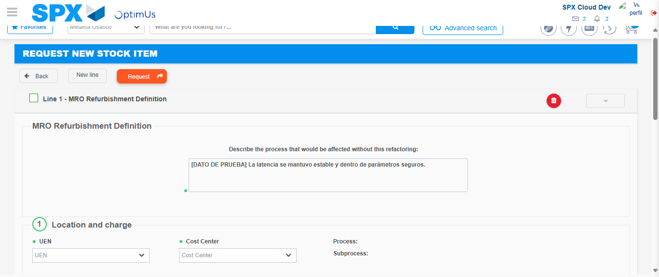Image file-name: QC_Testing-tc001_SPX_Dev5_Crear_Solicitud_Articulo_Almacen-1787938713841

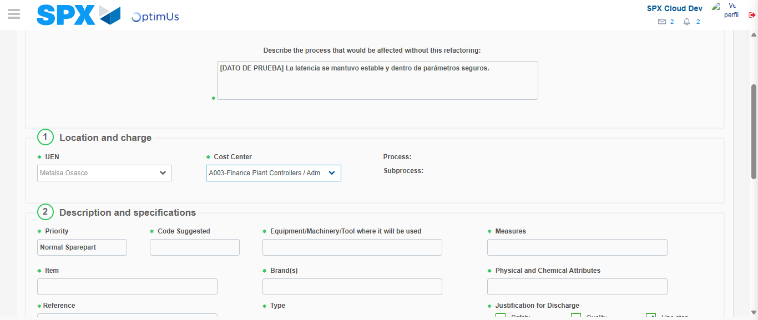Image file-name: QC_Testing-tc001_SPX_Dev5_Crear_Solicitud_Articulo_Almacen-1787938716322

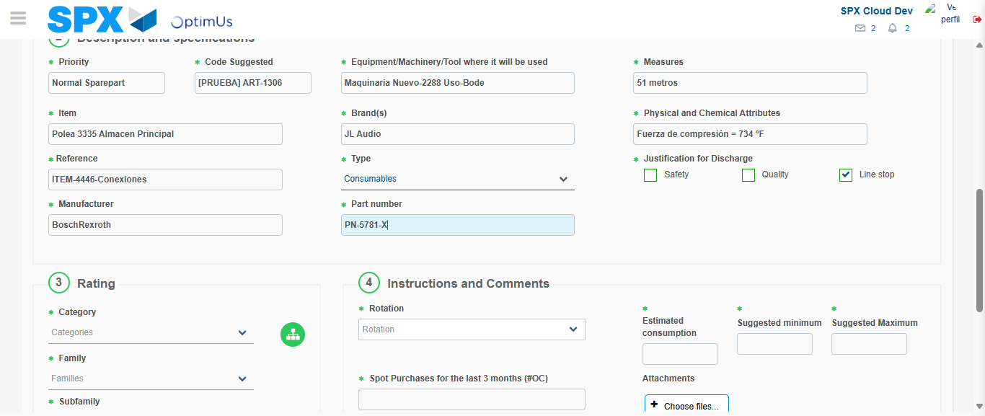Image file-name: QC_Testing-tc001_SPX_Dev5_Crear_Solicitud_Articulo_Almacen-1787938717770

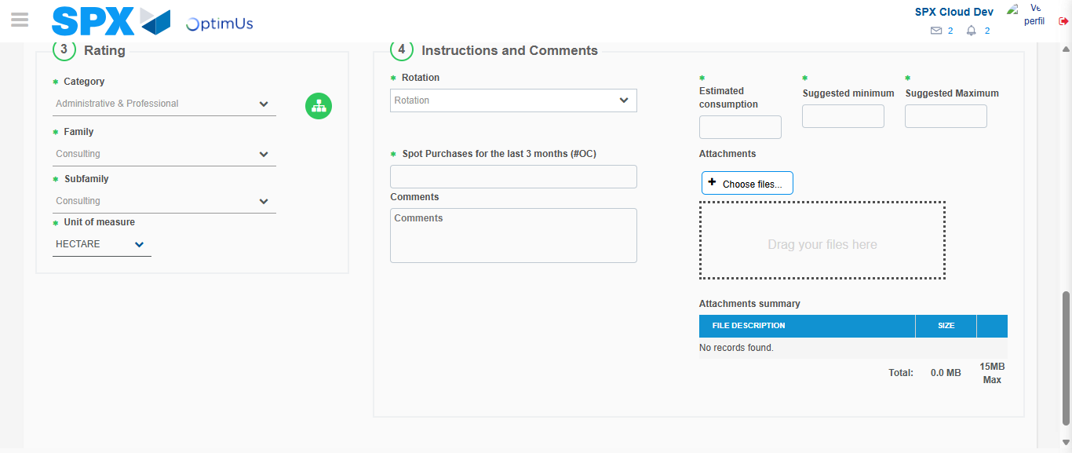Image file-name: QC_Testing-tc001_SPX_Dev5_Crear_Solicitud_Articulo_Almacen-1787938722164

Step 5 - Request New Item : Request Accepted
Image file-name: QC_Testing-tc001_SPX_Dev5_Crear_Solicitud_Articulo_Almacen-1787938677310

Image file-name: QC_Testing-tc001_SPX_Dev5_Crear_Solicitud_Articulo_Almacen-1787938677772

Image file-name: QC_Testing-tc001_SPX_Dev5_Crear_Solicitud_Articulo_Almacen-1787938700439

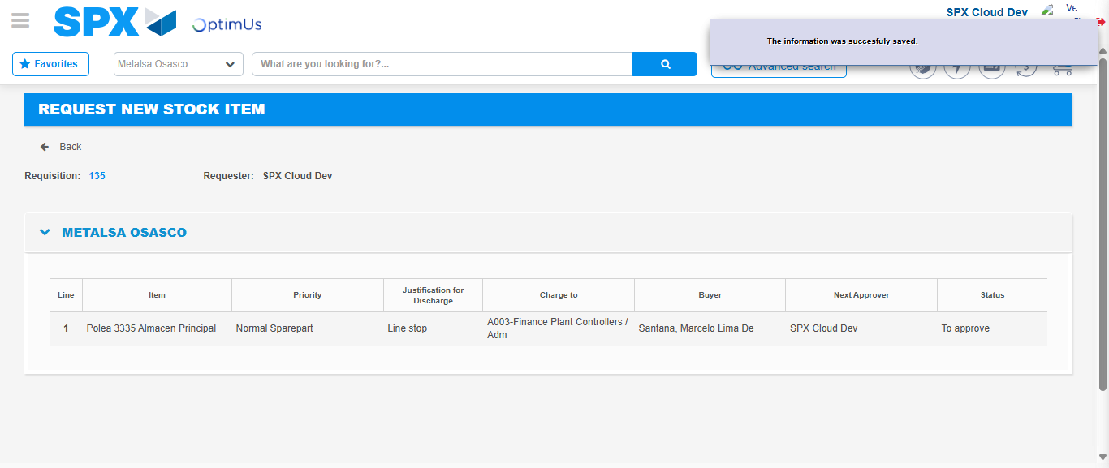Image file-name: QC_Testing-tc001_SPX_Dev5_Crear_Solicitud_Articulo_Almacen-1787938729498

Image file-name: QC_Testing-tc001_SPX_Dev5_Crear_Solicitud_Articulo_Almacen-1787938729677

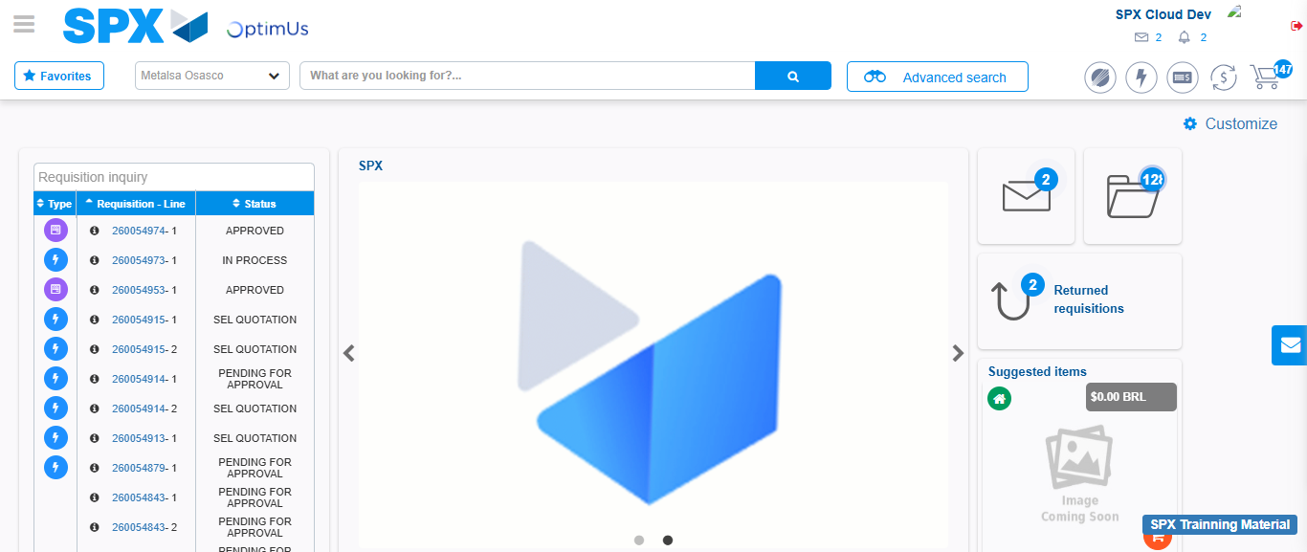Image file-name: QC_Testing-tc001_SPX_Dev5_Crear_Solicitud_Articulo_Almacen-1787938751023

Step 7 - Return to Main Page SPX : Return to Main Page SPX
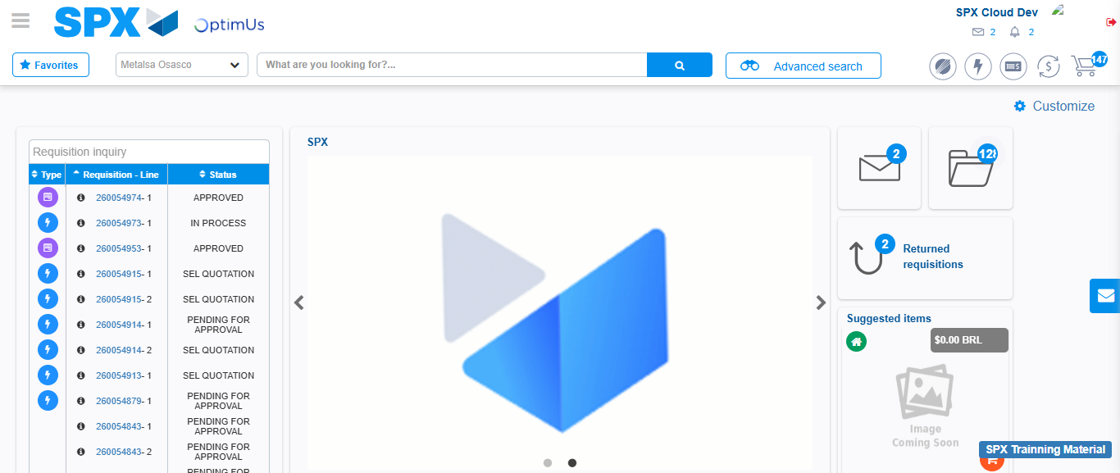Image file-name: QC_Testing-tc001_SPX_Dev5_Crear_Solicitud_Articulo_Almacen-1787938751408

